<https://www.youtube.com/watch?v=-WEpWH1NHGU>

Top 65 SQL Interview Questions and Answers | SQL Interview Preparation | SQL Training | Edureka

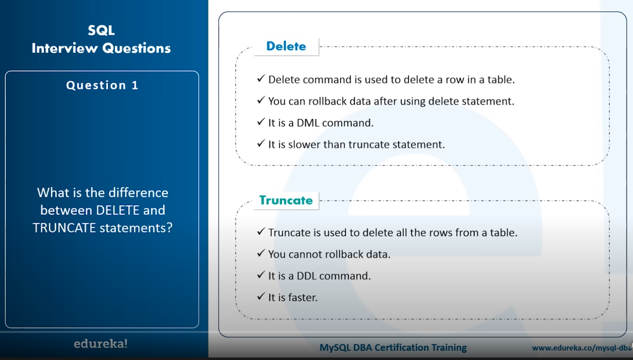

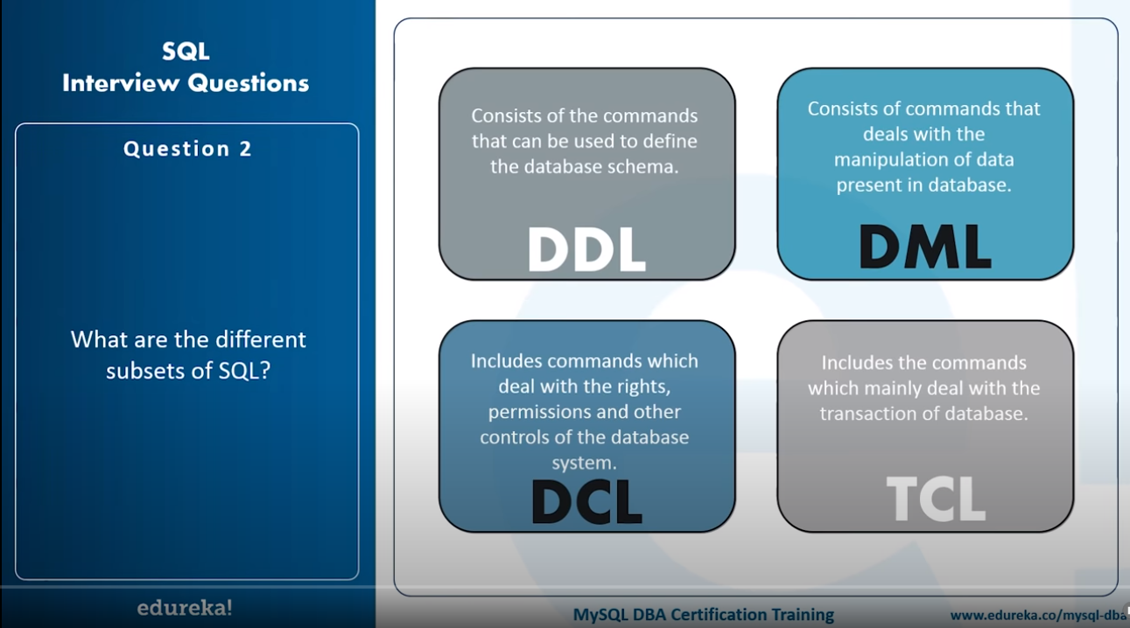

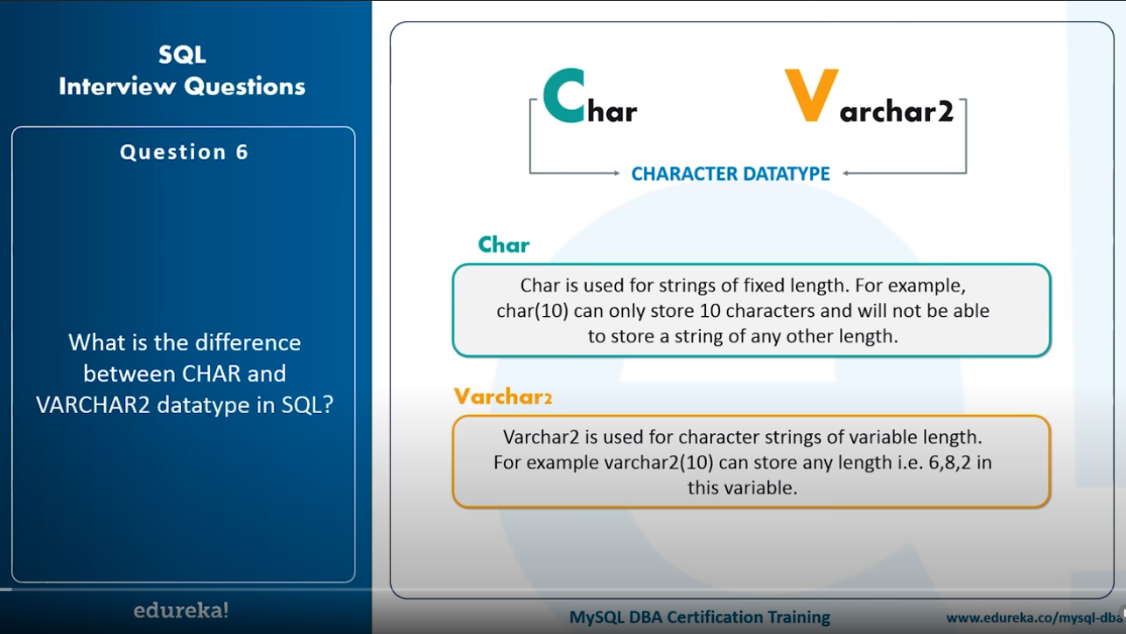

What is a Primary Key?

A set of attributes that can be used to uniquely identify every tuple is a primary key.

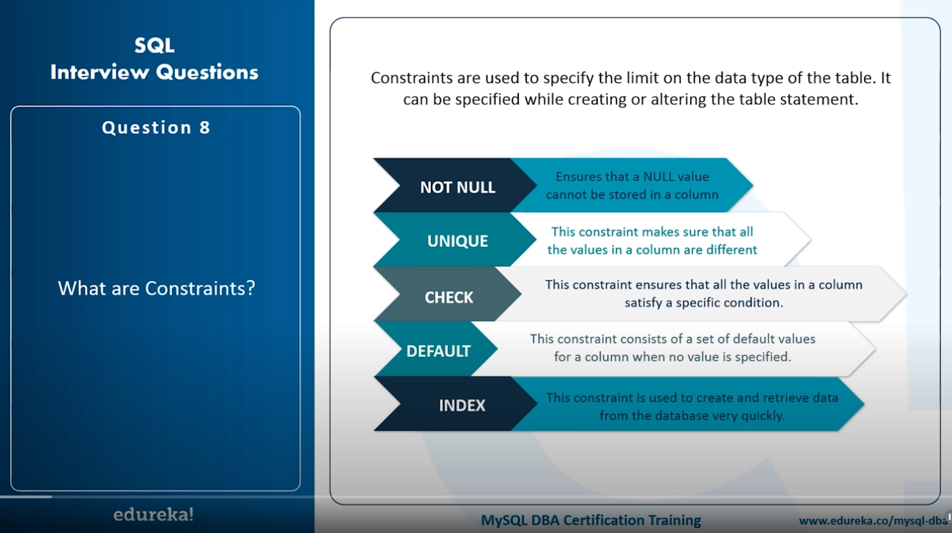

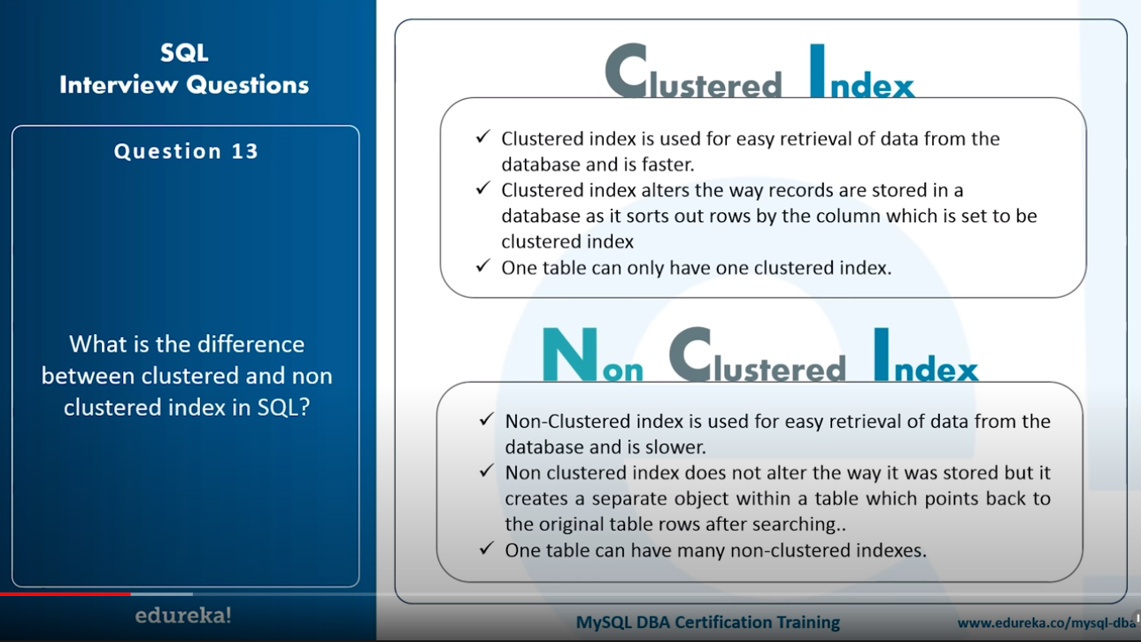

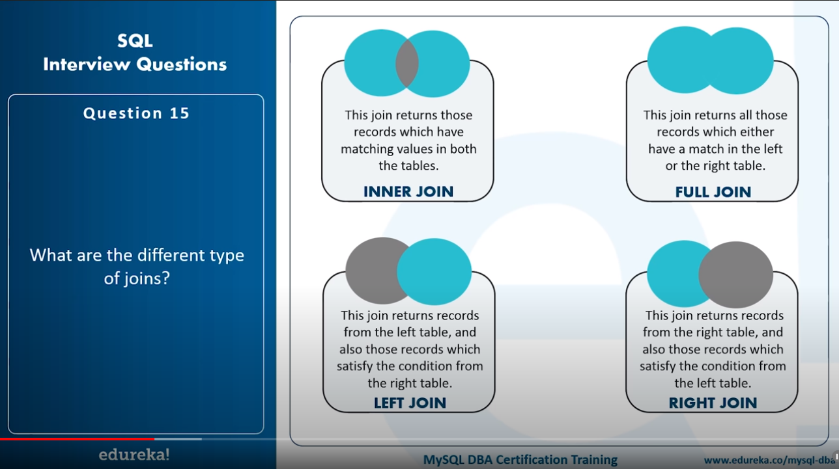

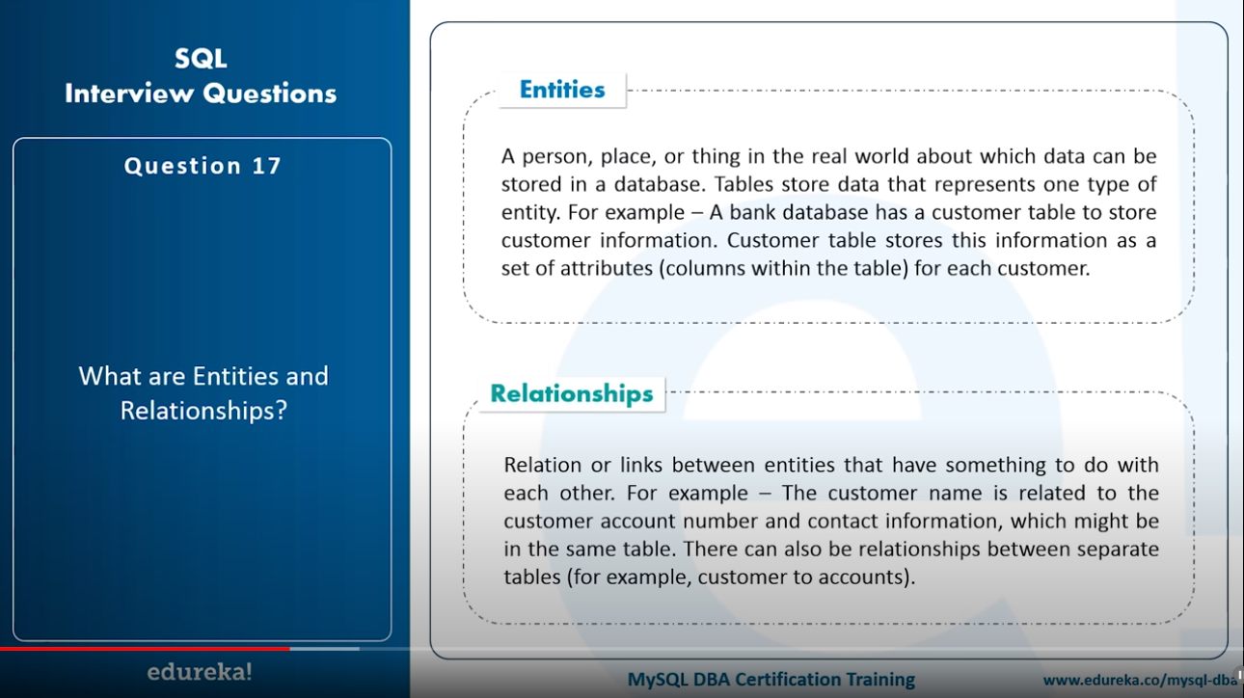

* Index: Performance tuning method allows faster retrieval of records from the table. Creates an entry for each value.
* Unique Index: This index does not allow the field to have duplicate values if the column is unique indexed. If a primary key is defined a unique index can be applied automatically.
* Clustered Index: This index reorders the physical order of the table and searches based on the key values. Each table can only have one clustered index.
* Non-clustered index: Non-clustered index does not alter the physical order of the table and maintains a logical order of data. Each table can have many non-clustered indexes.

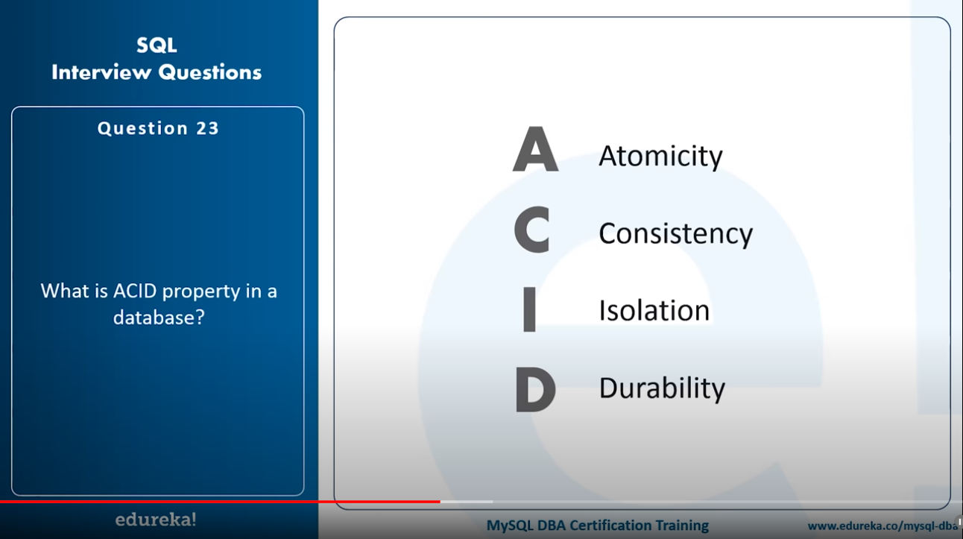

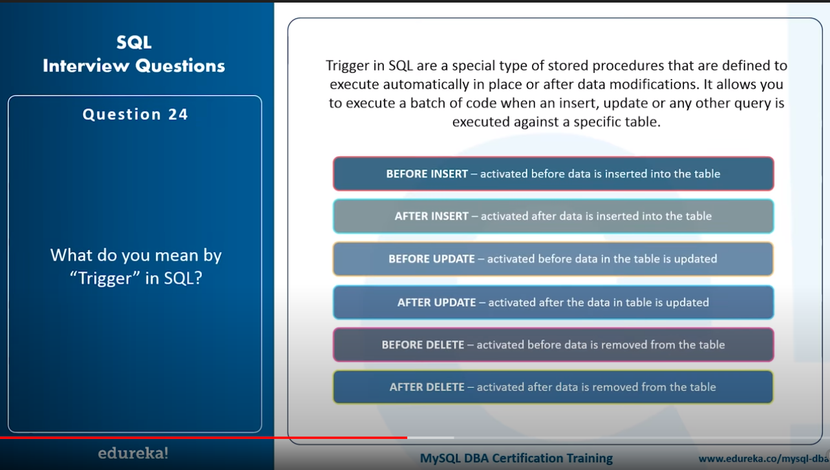



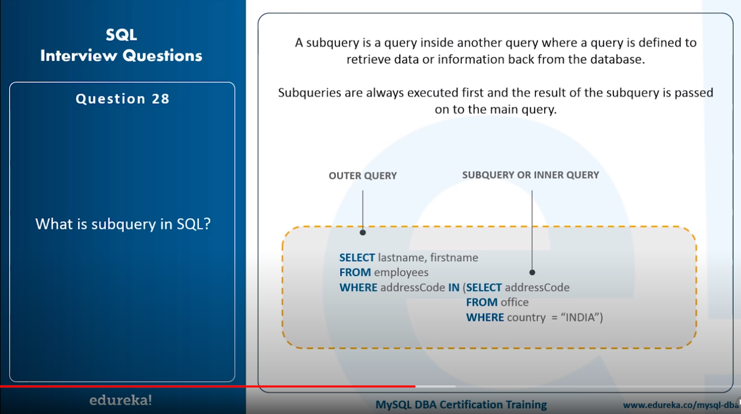

Corelated Subquery:

These are query which select the data from a table referenced in the outer query. It is not considered as an independent query as it refers to another table and refers the column in a table.

Non-Corelated Subquery:

* This query is an independent query where the output of subquery is substituted in the main query.
* To count the number of records in a table, you can use the below commands:

SELECT * FROM table1;

SELECT COUNT(*) FROM table1;

SELECT rows from sysindexes where id = OBJECT_ID(table1) indid < 2;

* Write sql query to get the third highest salary of an employee from employee_table

Select top 1 salary from (

Select top 3 salary

From employee_table

Order by salary desc

) as emp order by salary asc;

